Brief look through the data files.

* Hackathon 2020
* Hackathon Categories Information
* Hackathon Data
* Hackathon Panelists Data

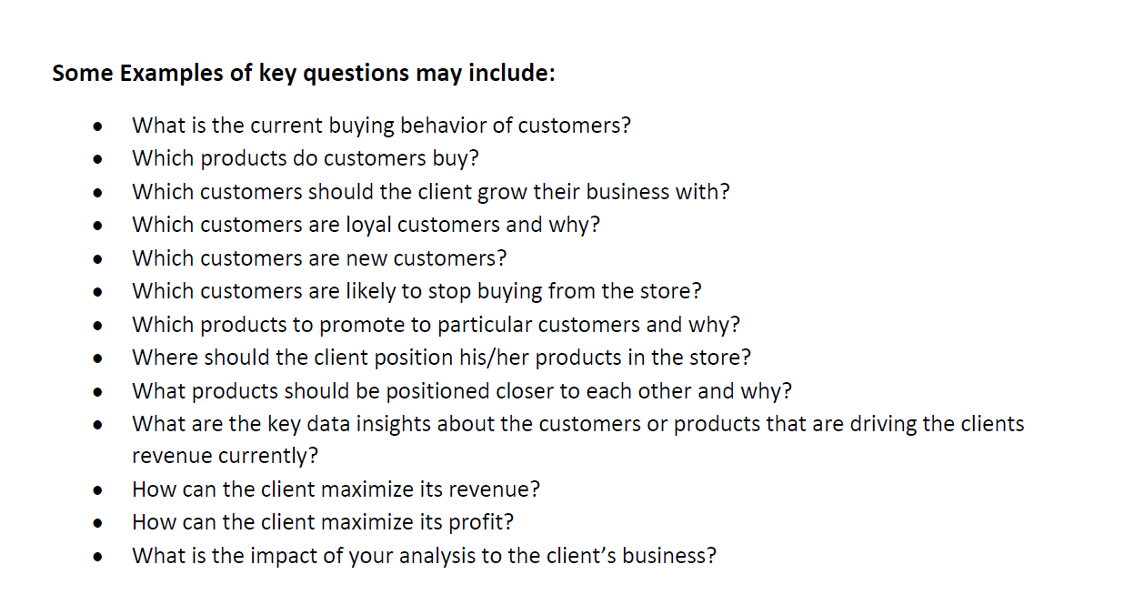

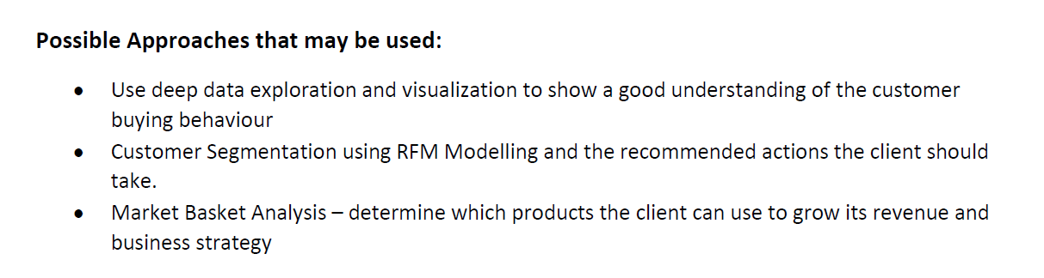

By Sunday: Try to answer as many questions as possible for Assignment 1, do state your assumptions made. Our report and code can be in the same Python Notebook file. Our presentation will be on slides.

You can use Tableau, R and other software you are familiar with.